Christopher Aucoin

Mr. Duhon

1. Top down design is used when you want multiple functions each doing one task to contribute to a combined output. Recursive functions, however, will find an answer by calling itself continually until it gets the answer it wants.

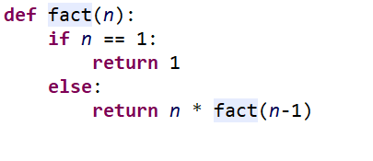

1. Using a recursive function is more efficient and better for storage because it can compact what is done by multiple functions into one. It is however, harder on the memory as each call made within the function has to be stored within the RAM so if you call the function too many times then you will cause an error.
2. It says that the name ‘n’ is not found
3. Maximum recursion depth exceeded while calling a python object
4. Olleh
5. “”